**1. INTRODUCTION**

In this problem, we are going to visualize the motion of a spherical bead rolling back and forth in a stationary circular hoop. To do so, we will animate the motion in Matplotlib with the help of our recently-learned techniques.

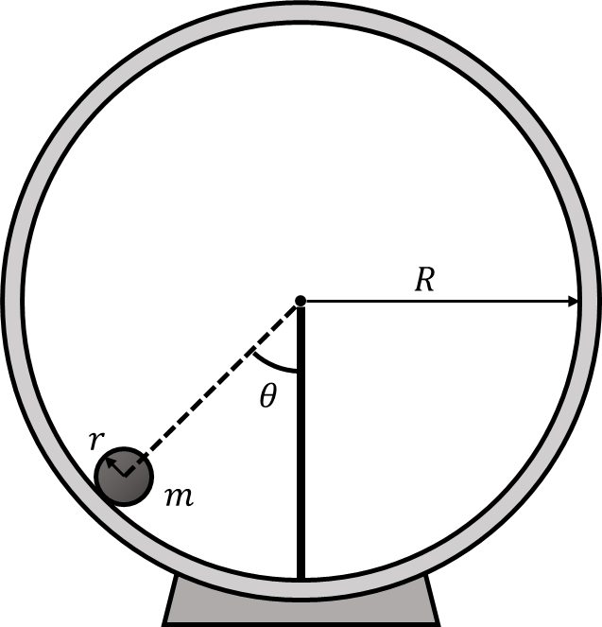**2. PROBLEM STATEMENT**

A solid bead with radius $r$ and mass $m$ is released at one side of a circular hoop with radius $R$. The bead rolls without slipping down and back up the ramp, making an angle $θ$ with the vertical as shown in the figure on the right.

In the assumption that $θ$ is small and $R≫r$, the equation of motion for the hoop is as written below:

$$θ\left(t\right)=θ_{0}\cos\left(\sqrt{\left(\frac{5}{7}\right)\frac{mg}{R}}t\right)$$

Using Matplotlib, animate the motion of the bead on the hoop and create a plot of $θ$ with respect to time.

**3. CHECKING YOUR RESULTS**

To check your results, compare your solution with the provided solution files in the GitHub repository. Not all solutions will be identical – the provided solution is meant to be used as a guide if you get stuck.

**4. TABLE OF CONSTANTS**

|  |  |
| --- | --- |
| $$θ_{0}$$ | $$\frac{π}{4} rad$$ |
| $$m$$ | $$3.15 ×{10}^{-2} kg$$ |
| $$g$$ | $$9.81 m∙s^{-2}$$ |
| $$R$$ | $$1.25 ×{10}^{-1} m$$ |
| $$r$$ | $$1.50×{10}^{-2} m$$ |

**5. APPENDIX**

This problem involves converting from polar to rectangular coordinates. The angle of the particle on the hoop with respect to the vertical must be expressed in terms of x and y coordinates to be plotted. As shown below, assuming $R≫r$ and placing the center of the hoop at the origin, the x and y positions of the bead are $-R\sin\left(θ\right)$ and $-R\cos\left(θ\right)$ respectively.

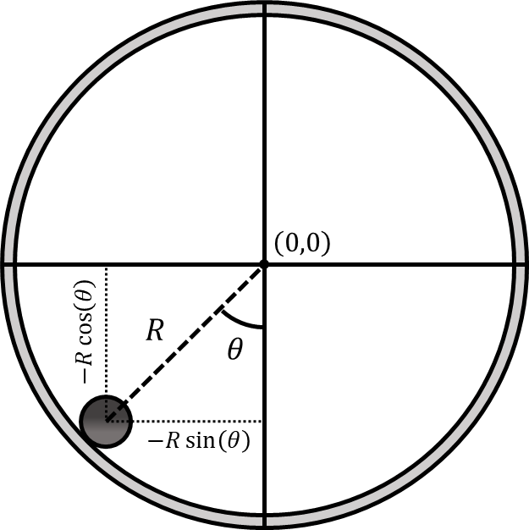

When animating the motion, we must offset the bead by a distance $r$ from the hoop so that the edge of the bead, not the center, is in line with the hoop. In rectangular coordinates, this involves adding $r\sin\left(θ\right)$ and $r\cos\left(θ\right)$ to the x and y positions respectively as depicted below.

